Aa Arts & Literature
Kenya’s art and culture is unique. The people, traditions, customs, society, music and dance help to shape Kenya’s arts and literature. Swahili is the oldest and main cultures followed by the Maasai culture. Kenyan artist create traditional, tribal masks, mats, baskets and other products.

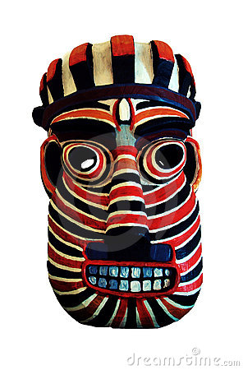
Kenyan tribal mask.
Ee Economy
Kenya’s economy is developing. One third of the economy is based on agricultural products such as coffee, tea, cashews, cotton, and pineapples. Second to agriculture is the tourism industry. Over ½ a million tourist sojourn to Kenya each year to enjoy the scenic coast and to photograph wildlife while on safari’s.’

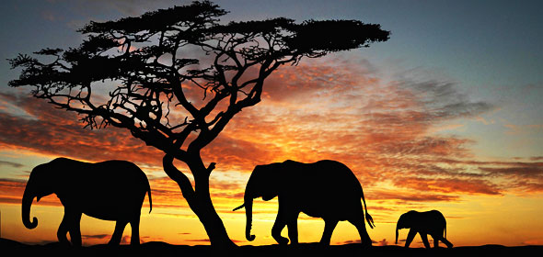
Picturesque view of Kenyan wildlife camp.

