**Document 1**

Picture

**Questions**

1. Describe the picture by listing 5 details about it.

2. What do you think they are holding in their hands (be detailed-don’t just say book-what kind of book)?

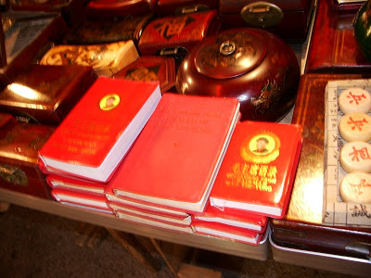

Mao’s *Little Red Book*

**Document 2**

The following quotations are adapted from Mao Zedong’s *Little Red Book* (1964)

“A revolution is not a dinner party, or painting a picture, it cannot be leisurely, gentle, kind, courteous, and restrained. A revolution is an act of violence by which one class overthrows another.”

“Political power grows out of the barrel of a gun.”

“Just because we have won a victory, we must never relax our vigilance (watchfulness) against the mad plots of revenge by the imperialist.”

**Questions**

1. Define the word revolution.

2. According to these quotations from Mao Zedong, what were his methods (ways to achieve your goals) and goals (what he wants to happen)?

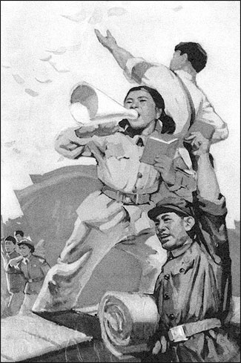

**Document 3**

This is a 1967 poster showing Red Guards speaking through a megaphone and distributing leaflets. Their poses are part of a standard set up that run through many different forms of revolutionary art, including films, plays, paintings and sculpture. This type of pose became the body language that was embraced by many young enthusiasts during the Cultural Revolution, in a process of life imitating art.

**Questions**

1. Who do you think the Red Guards are and who do you think they support?

2. Describe the pose of the guard. Why do you think this is the pose?

The world belongs to you.It belongs to us as well, but ultimately it’s yours.You young people are … just like the morning sun.You embody the hope of the future.— Mao Zedong

**Document 4**

Quote

**Questions**

1. Define embody.

2. What does Mao mean by this quote? Put in your own words.

3. Why are the youth so important in his plan?

<http://academics.wellesley.edu/Polisci/wj/China/CRSongs/Commune/littlecommune.htm>

(go to this website and listen to the song and the translation is below)

**Document 5**

I am a little member of the commune,  
with a little sickle in my hand,  
and a bamboo basket on my shoulder.

I go to work after class, cutting weeds, collecting manure, and picking up the lost wheat ears.  
The more I work, the more I love it.

Ayh-hey-hey, Aye-hey-hey,

Always keeping in mind the good character of the poor-and-lower-middle peasants,  
Loving the collective and loving labor,  
I am a little member of the commune!

**Questions**

1. Define the word commune.

2. What is the attitude of this commune member? Why do you think that’s his/her attitude? Do you think it is really her true feelings?

3. Would you like to be a member of this commune? Why or why not?

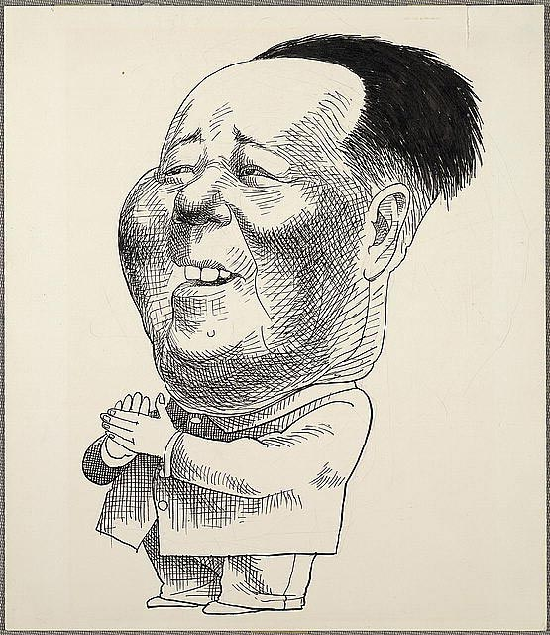

**Document 6**

Mao Zedong (1893-1976) rose from humble origins to become chairman of the Chinese Communist Party and main founder of the People's Republic of China. As a young man he was strongly influenced by Marxism and helped create the Chinese Communist party in Shanghai in 1921. An uprising of poverty-stricken peasants in Hunan province in 1927 deeply affected him, awakening his beleifs that peasant unrest should get Communist support. Through years of war and political struggle, he built the Chinese Communist Party and Red Army into dominant national forces. In October, 1949, he proclaimed the establishment of the People's Republic of China and was elected President. Though Mao could be ruthless, he is remembered as a consistent champion of China's neglected peasantry.

**Questions**

1. In what year did Mao take control of China and what did he call the country?

2. Is this new name Mao established a correct representation of the government Mao created in China? Why or why not?

3. Why do you think Mao in his caricature was represented by a big head?

**Document 7**

In this excerpt, Nien Cheng describes the experience of a friend during the Great Leap Forward program (under Mao).

“When Li Zhen (a famous Chinese teacher and friend of the author) returned to Shanghai, the city was suffering from a severe food shortage as a result of the catastrophic economic failure of the Great Leap Forward Campaign launched by Mao Zedong in 1958. Long lines of people were forming at dawn at Shanghai police stations, waiting to apply for exit permits to leave the country. This was such an embarrassment for the Shanghai authorities that they viewed Li Zhen’s return form affluent Hong Kong to starving Shanghai as an opportunity for propaganda”.

Source: Nien Cheng, *Life and Death In Shanghai*, Grove Press, 1987

**Questions**

1. Define propaganda.

2. What was the effect of the Great Leap forward on the people?

3. Why was Li Zhen’s return a “good thing” for the Great Leap Forward Program?

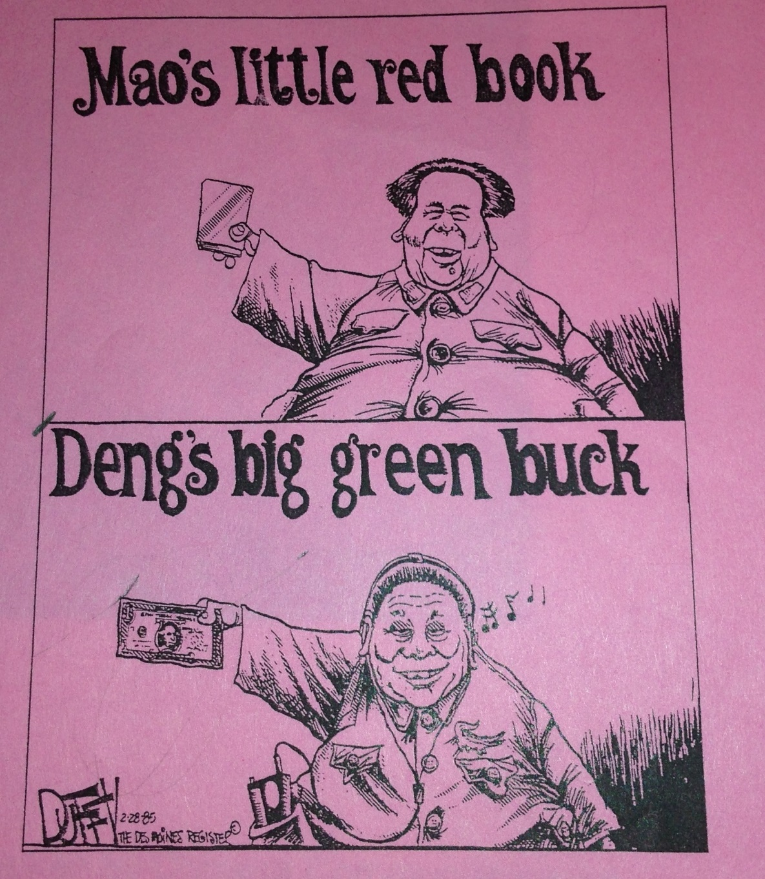

**Document 8**

Political Cartoon

**Questions:**

1. Who is “Deng” mentioned in the bottom cartoon? What is he famous for?
2. According to the cartoon, how were the policies (laws) of Mao and Deng different?

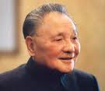

**Document 9:**

These quotations were spoken by Chinese Communist leader, Deng Xiaoping

“It doesn’t matter whether the cat is black or white, so long as it catches the mice.”

“To get rich is glorious.”

“If you open the window, some flies naturally get in.”

**Questions:**

1. Pick one of the quotations and explain what it means.
2. According to these quotations, what was Deng’s economic policy?
3. How does that policy differ from the policy of Mao?

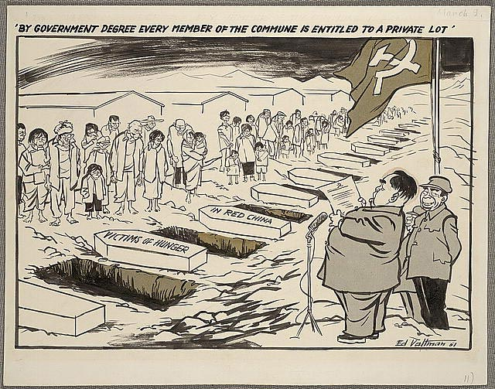

In 1961, after a period of disastrous weather, Communist China experienced a severe agricultural famine. The government was forced to change its policies, relaxing centralized controls of the agricultural communes and even giving the farmers the right to farm their own plots. Valtman (the artist) suggests that the only plots that many Chinese will receive will be their own graves. This cartoon was one of the group that Valtman submitted when he won the Pulitzer Prize in 1962.

**Document 10:**

Political Cartoon

**Questions:**

1. Define famine
2. What did the famine require Mao’s government to do? (be specific)
3. Explain what the cartoon is saying.

# Great Leap Forward

The Great Leap Forward was a failed industrialization by the Chinese communists between 1958 and early 1960. [Mao Zedong](http://encyclopedia2.thefreedictionary.com/Mao+Zedong) hoped to develop labor-intensive methods of industrialization that would emphasize manpower rather than the gradual purchase of heavy machinery. So putting to use China's dense population and getting rid of the need to get capital (outside money). Rather than building large new factories, he proposed developing backyard steel furnaces in every village. Rural people were organized into communes where agricultural and political decisions were made based on communist beliefs rather than expertise. The program was implemented so hastily and without question that many errors occurred; these were increased by a series of natural disasters and the withdrawal of Soviet (Russian) technical personnel. China's agriculture was severely disrupted, causing widespread famine in 1958–62. By early 1960 the government had begun to repeal (take away) the Great Leap Forward; private plots were returned to peasants, and expertise began to be emphasized again.

**Document 11**

**Questions**

1. Explain the Great Leap Forward.

2. What was one effect of the Great Leap Forward?

Little Red Book

During the Chinese Cultural Revolution, there was a book that had as much power as the Bible, and in some situations, even more. What kind of book was it? How did it gain the unbelievable power? Who gave the book the power to control every single person in China during that time?

The book's official name should be "the Quotes of Chairman Mao," however, people always call it "Little Red Book." As in its name, this book is the collection of Mao's quotes. This book was edited by Lin Bao, who was once considered as Mao's successor. Lin edited the "little red" book to earn Mao's confidence, he wanted to stabilize his status in the Chinese Communist Party. During the Chinese Cultural Revolution, this red book was popularly used by the Little Red Guard, which created the cult of Mao. Although this book seems to have endless power, the content of the little red book was not significant at all. Mao's quote were not clear most of the time, and after the book became all powerful, people could easily get out of trouble simply by quote from the book to explain their false behavior. This book was not the source of the happening of the Chinese Cultural Revolution, however, it was responded for lots of mad actions happened. After the Chinese Cultural Revolution ended, the power of the little red book became less than it used to be. However, since Mao is still the "hero" or "god" to many Chinese people's, the little red book still influences the society in China.

**Document 12**

**Questions**

1. Who wrote the book?

2. What was the *Little Red Book* written about?

Cultural Revolution Information

The Cultural Revolution had a massive impact on [China](http://www.historylearningsite.co.uk/china_1900_to_1976.htm) from 1965 to 1968. The Cultural Revolution is the name given to [Mao’s](http://www.historylearningsite.co.uk/mao_zedong.htm) attempt to reassert his beliefs in [China](http://www.historylearningsite.co.uk/china_1900_to_1976.htm). Mao had been less than a dynamic leader from the late 1950’s on, and feared others in the party might be taking on a leading role that weakened his power within the party and the country. This probably explains the Cultural Revolution – it was an attempt by [Mao](http://www.historylearningsite.co.uk/mao_zedong.htm) to re-impose his authority on the party and therefore the country.

Mao believed that the progress China had made since 1949 had lead to a privileged class developing – engineers, scientists, factory managers etc. Mao also believed that these people were acquiring too much power at his expense. Mao was concerned that a new class of mandarins was emerging in China who had no idea about the lifestyle of the normal person in China.

Red Guards (groups of youths who banded themselves together) encouraged all the youth in China to criticise those who Mao deemed untrustworthy with regards to the direction he wanted China to take. No-one was safe from criticism: writers, economists and anyone associated with the man Mao considered his main rival – Liu Shao-chi. Anyone who was deemed to have developed a superior attitude was considered an enemy of the party and people.

Mao deliberately set out to create a cult for himself and to purge the Chinese Communist Party of anyone who did not fully support Mao. His main selling point was a desire to create a China which had peasants, workers and educated people working together – no-one was better than anyone else and all working for the good of China – a classless society.

However, the enthusiasm of the Red Guards nearly pushed China into social turmoil. Schools and colleges were closed and the economy started to suffer. Groups of Red Guards fought Red Guards as each separate unit believed that it knew best how China should proceed. In some areas the activities of the Red Guard got out of hand. They turned their anger on foreigners and foreign embassies got attacked. The British Embassy was burned down completely.

In October 1968, Liu Shao-chi was expelled from the party and this is generally seen by historians as the end of the Cultural Revolution. Mao had witnessed the removal of a potential rival in the party and therefore saw no need for the Cultural Revolution to continue.

**Document 13**

**Questions**

1. Why did Mao establish the Cultural Revolution?

2. Who were the Red Guards and what did they do?

3. What were some of the changes made in China during this time period?

Retrieved from: https://www.google.com/webhp?complete=0&gws_rd=ssl#safe=strict&complete=0&q=china+have+a+red+and+black+class+if+they+wanted+a+classless+society