India Unit Test | Study Guide – DUE

Name_______________________________ Red Green Yellow Blue

Identify the following landforms on the map of India below:
Ganges River, Deccan Plateau, Indus River, Bay of Bengal, Indian Ocean, and Himalayan Mountains.
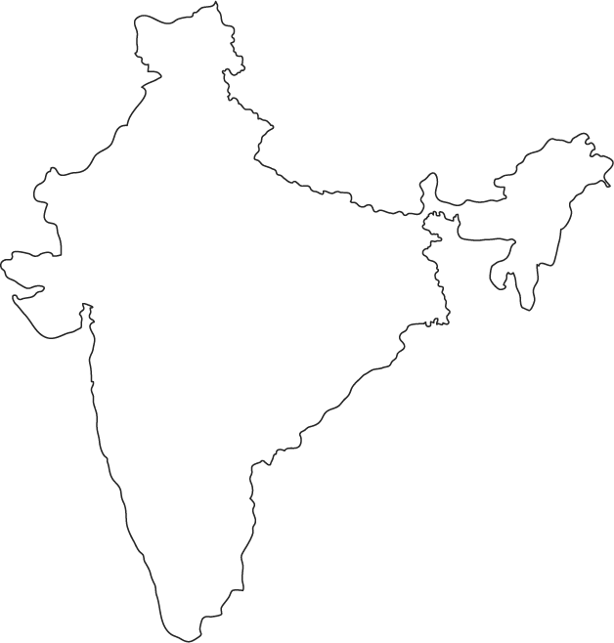

Why is the Ganges considered such an important river? How has it influenced daily life AS WELL AS religion? (CRCT Book p. 134)
The river provides fertile soil for farming and plays a role in religion
The river provide water and transportation for over 400 million people

Describe an environmental issue associated with the Ganges River. (CRCT Book p. 134)
Chemicals used in fertilizer and industry
Human and animal waste
Bodies of dead animals and cremated remains
Sewage poured into river

Define Asian Brown Cloud and explain its cause, effect and environmental/human impact. (CRCT p. 137)
Haze of pollution
Rainfall had decreased and temperatures are cooler

Define monsoon and explain its environmental/human impact. (CRCT p. 140)
Seasonal winds that help to shape the climate of India
Brings much needed rain, but also cause flooding.

Describe Hinduism. When was Hinduism founded? (CRCT Book p. 146)
Hinduism was founded around 1500 B.C.
By the Aryans
Living things have souls
Reincarnation and nirvana are tenants of the religion

What is karma? What is reincarnation? (CRCT Book p. 146)
Karma- belief that one’s action determines their fate
Reincarnation-the soul does not die with the body but enters another form

Describe Buddhism. Where was Buddhism founded? (CRCT Book p. 147)
Belief that people can find peace by rejecting greed and desire
Founded 500 B.C. in India
Founded by Siddhartha Gautama

What is the caste system? How is your caste determined? (CRCT Book p. 146)
Hindu practice focusing on social status which determines your career, hereditary, will remain in that caste your entire life

What was the British Raj?
Raj means rule in Hindi. British rule in India from 1858-1947.

What was the East India Company? Why was it established? How did it impact India? (British Conquest of India PPP)
Formed a monopoly and also controlled politics in India
Exploit India’s resources and share in the East Indian Spice trade
Controlled all aspects of Indian life and made Indians second class citizens in their own country

Define imperialism. How did it play a role in India’s history? (British Conquest of India PPP)
Extending the power of a nation by gaining control of its territories
Great Britain controlled all aspects of Indian life and made Indians second class citizens in their own country

Who was Gandhi? Explain his concept of non-violence. (CRCT Book pp. 187 & 193)

Define civil disobedience. (CRCT Book pp. 187 & 193) What was the reason for Gandhi’s Salt March? (CRCT p. 193)
The nonviolent refusal to obey an unfair law
To resist British taxes that did not benefit the Indian people

What was the Rowlatt Act and its impact on native Indians? (CRCT p. 187)
Allowed Indian citizens to be imprisoned for up to two years without a trial

Define nationalism. How did nationalism play a role in India’s independence? (CRCT p.187)
loyalty and love of one’s country; the belief that your country is the best
people began to get upset that their country was a part of the British empire

What happened during the Amritsar Massacre? How did it play a role in India’s independence movement?
(CRCT p. 193)
British Authorities opened fire on a large group of Indians, over 400 people were killed and 1200 others wounded
Indians all over were angry, wanted their independence
Define the Indian National Congress and Muslim League. How did religion play a role in India’s politics? (CRCT p. 187)

Explain the reasons for the partition of India/Pakistan. (CRCT p. 188) What year did India gain its independence? (CRCT p. 188)
Disputes between Indian Hindus & Muslim Hindus
Only way to stop fighting between the 2 groups
1947

What type of government does India have? Who is allowed to vote? (CRCT p. 164)
Democratic Republic & a parliamentary democracy/All citizens over the age of 18
What type of economy does India have? (CRCT p. 169) What was the Green Revolution? (CRCT p.171)
Mixed Economy
In India (1960’s) new types of seeds and grains were introduced & fertilizers and pesticides were made available improved India agriculture
Why are so many people migrating to India’s cities? (CRCT Book p. 142)
People are moving into the cities from rural areas in large numbers looking for work and better opportunities for their families.

Why are urban areas in India experiencing issues with pollution? Why are rural areas having problems as well?
(CRCT Book p. 137)
The rapidly growing population, heavy industry, and thousands of automobiles have caused the problem
Millions of people cook over wood or coal fires

BE ABLE TO ANALYZE POLITICAL CARTOONS FOR THE TEST AS WELL

