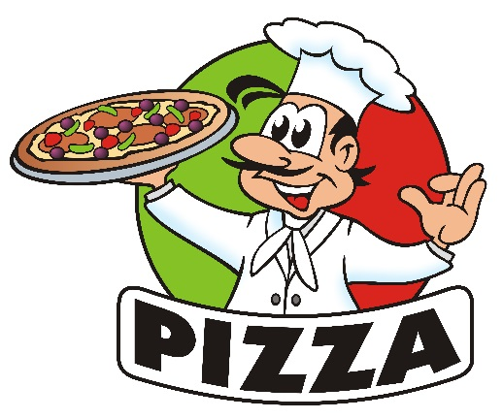
You just purchased your own pizza shop! You’re excited about your new pizza shop; however, you have to operate within the guidelines of your country’s economic system.
TASK- List and describe as many resources you will need to operate your new pizzeria. However, you must explain how your assigned economic system answers the three basic economic questions.
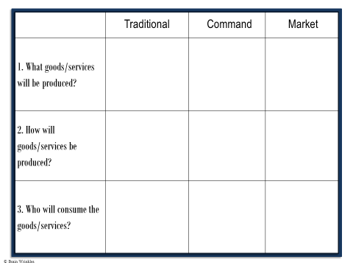

ANSWERS
Traditional Economy
What? In a traditional economy, the people will follow tradition and make a bread type pizza. Pizza is NOT a tradition in this type of economy. In addition, a lot of the luxuries we have to create a pizza may be absent in the traditional economy.
For example, those in a traditional economy probably will not have an electric oven to bake bread or a refrigerator to store food items needed to make pizza. Bread is common in MOST cultures, so any topping available leafy vegetable, fish, pineapple, mushrooms, and seeds.
How? In traditional economies, a wood oven is common. If a food item similar to pizza was made, it would probably be made in the home or a family business. Maybe, sold from a push cart for convenience.

Who? Pizza would be sold or maybe even given away to people in a village who may be hungry.

Command Economy
What? In a command economy, the government will determine the variety of pizza to be served. Pizza is common in command economies, however the number of choices/combinations such as toppings and types of dough might be limited.

How? Pizza will be produced in a similar manner as the market economy. Technology needed to create pizza’s would be present and workers would also be available. Efficiency would be key to these establishments meeting success. Producing pizza quickly for large amounts of people would be the goal.

Who? The government may have pizza shops located in areas where tourism is high. They will make money off of people looking for a quick meal they’re familiar with. In addition, all residents of a command economy would be welcome to purchase pizza if the government made it available in their area.

