Name:________________________________________________________________________________
The Scramble for Africa WEBquest
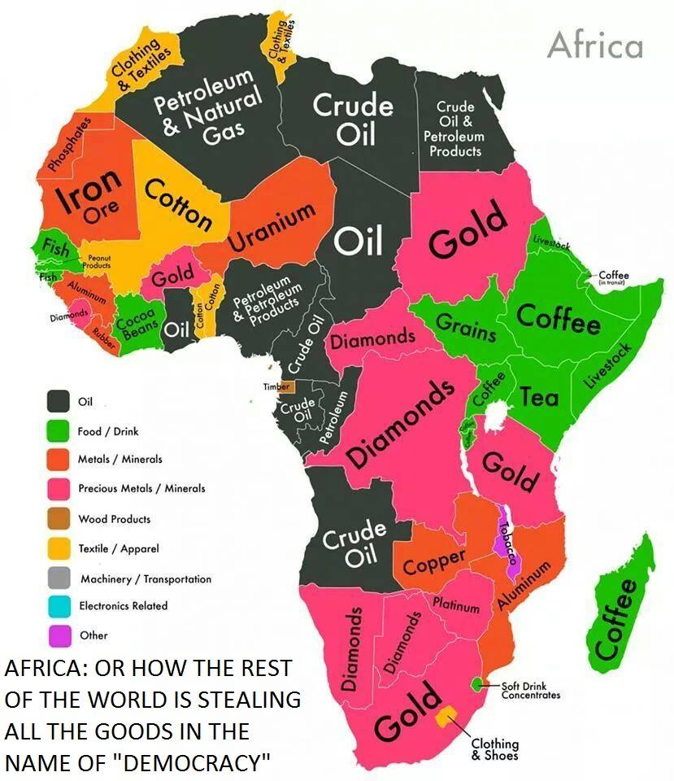
PART ONE: A. The Berlin Conference
1. List 3 reasons why Europeans wanted to take over Africa.

2. What was the Berlin Conference?

3. What agreements came out of the Berlin Conference?
(Summarize in a few words Articles 34 and 35)
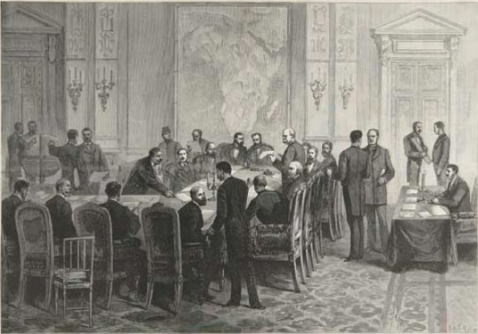
The Berlin Conference of 1884-1885.

4. What considerations were made by the Europeans to native Africans?

5. Make a Guess: How will the decisions made at the conference change Africa?

B. The “Scramble for Africa”
Make a Guess: What is the Scramble for Africa?

Answer the Questions based on the “scramble for Africa” Cartoon
1. According to the cartoon, which European countries were fighting for a position in Africa?

2. Make a prediction: How did the Berlin Conference lead to the situation shown in this cartoon?

Examine the maps
1. What is the main difference between the two maps?

2. What part did the Berlin conference play in the creation of Map 2?

3. What happened to the native political entities by 1914?

4. According to Map 2, which European countries held the most territory?
__________________________________________________________________________________________________
PART TWO: Use the map below to answer the question

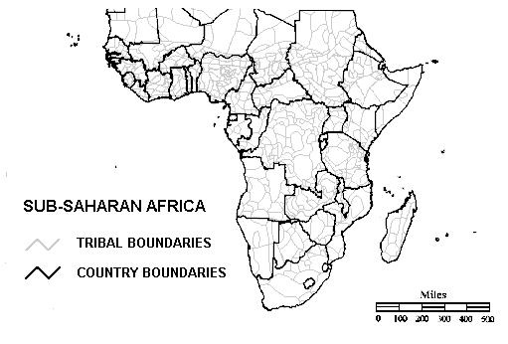
Background information: According to the key, the light black lines show tribal boundaries in Africa before European colonization. The bold black lines show the country boundary lines that exist today that were helped shaped by the Europeans. Before European colonization, tribal boundaries were used to separate territories in Africa.

1. Explain what happened to tribes when the Europeans made these new borders.

2. Using your answer for number 1, was this a good or bad thing? Explain why.

Part Three:Now…..PUT IT ALL TOGETHER AND ASNWER THE FOLLOWING:
1. How did European colonization and partitioning of Africa lead to present day conflicts and civil war?

______________________________________________________________________________________________________________________________________________________________________________________________________________________________________________________________________________________________________________________________________________________________________________________________________________________________________________________________________________________________________________________________________________________________________________________________________________________________________________________________________________________________________________

